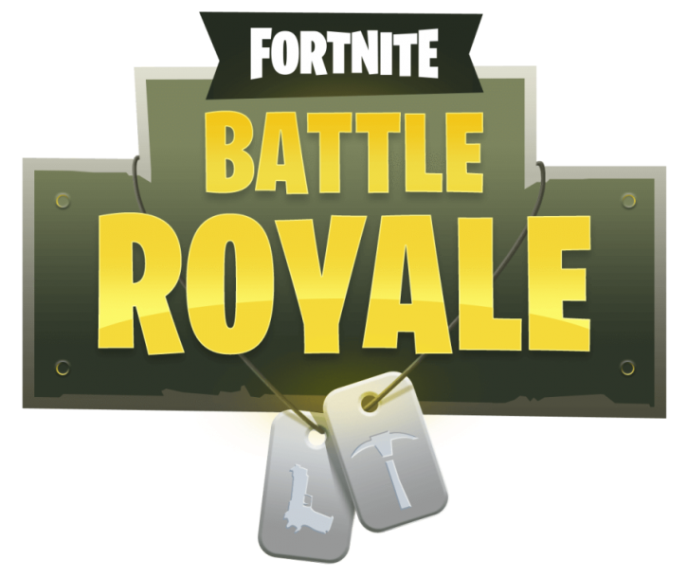
Welcome back to the second edition of Newshounds for the new decade! This time, we are going to take a look at one of the most popular games of today’s generation and let parents and carers know as much information as possible. Get ready to jump off the Battle Bus as we jump into the world of Fortnite Battle Royale!

Fortnite Battle Royale is a game developed and published by Epic Games (Previously known for the Gears of War franchise and creating the Unreal Engine)
It was released on September 26th 2017 as a ‘free to play’ game mode, as an update to the game.
Fortnite Battle Royale begins with you and up to ninety-nine other players jumping from the Battle Bus onto an island where players fight to be the last man/team standing by searching for loot in chests and eliminating other players. Along with this, there is an ever-shrinking border known as The Storm that forces players to come closer together, which quickly ramps up the pacing of gameplay.

Unlike many other games, Fortnite Battle Royale has a very ‘cartoony’ art style in comparison.
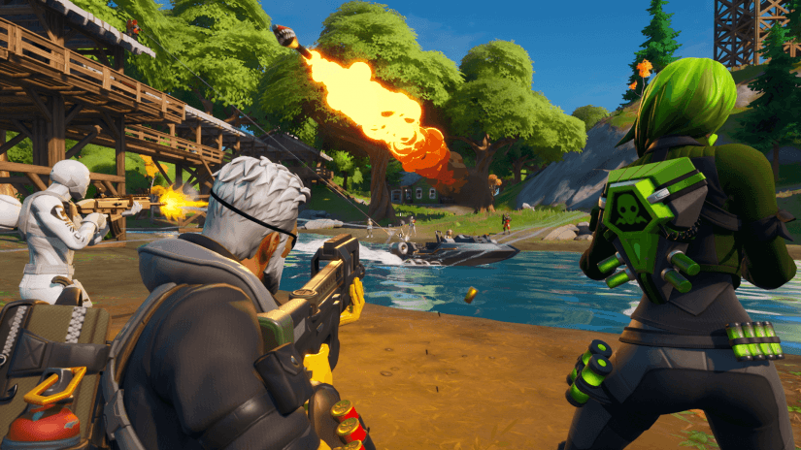
And the simplicity but sheer importance of the building and editing mechanics allows players to shake up the outcome of battles as a whole in a large variety of ways.
Along with this, Fortnite Battle Royale is constantly updating almost every week with new content such as weapons, items and more for players to discover. At the time of its release, Fortnite Battle Royale was the first game of its kind on consoles and the factor of ‘free to play’ quickly gave the game a community of its own.
According to PEGI (Pan European Game Information), Fortnite Battle Royale as a whole is rated PEGI 12 – twelve years and older. This is mainly due to ‘frequent scenes of mild violence’ although there is no blood or gore to be found.
It’s also worth noting that Fortnite Battle Royale has dialogue - however this is very few and far between. It is mainly within the Fortnite Save The World mode, which is the original mode for Fortnite Battle Royale, where players fight off against the ‘undead’, who are known as ‘husks’ and which revolves more around the ‘tower defence’ genre.
Fortnite Battle Royale can be played on PC, Mac, Xbox One, PS4, Nintendo Switch, IOS, and Android, but Fortnite Save The World cannot be played on Nintendo Switch, IOS and Android.
Fortnite Battle Royale is home to a large and ever-expanding range of ‘cosmetics’ that can change the look of your player in many different ways. Let’s take a brief look at them:

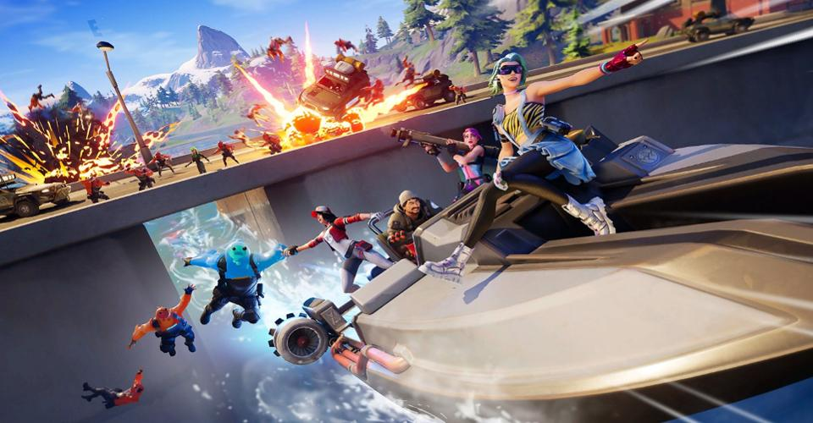
‘Outfits’: Commonly referred to as ‘Skins’, outfits are the main way to change your ‘in game look’ and there are (at the time of writing this) nearly seven hundred different outfits to choose from! These can range from the beloved ‘Slurp Monster Rippley’ to ‘real world’ icons such as ‘Mixer Streamer Ninja’, or even to characters from other popular franchises such as Star Wars.

‘Back Bling’: Many outfits come with Back Blings of their own, however these can be mixed and matched to create unique combos.

Here is a list of some beloved Back Blings:
Shattered Wing
Wolf Pack
Spectral Spine
Galactic Disk
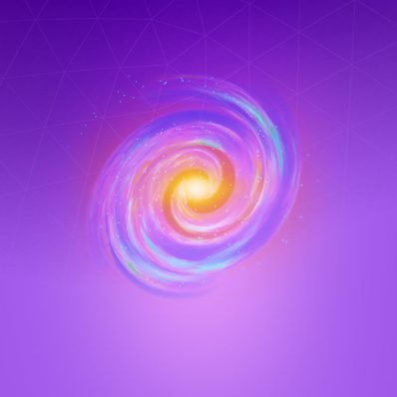
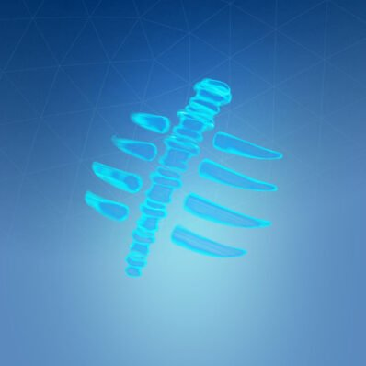
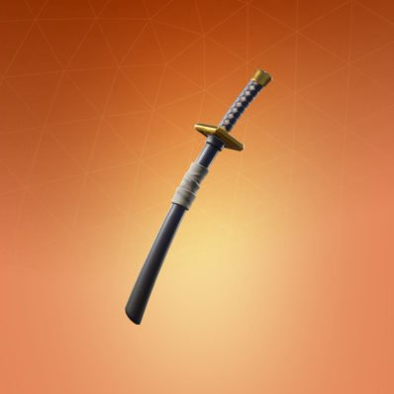

‘Harvesting Tool’: This is the way to gather resources for building structures and destroying structures. Some pickaxes can be ‘dual wield’ as well.

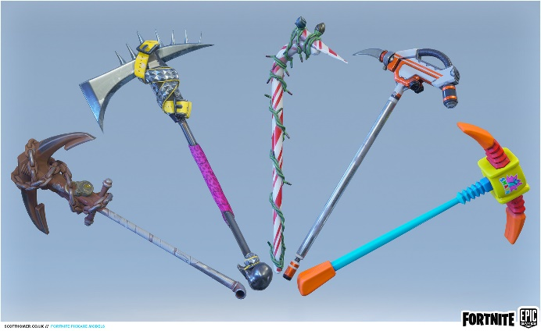
‘Gliders’: When jumping from the Battle Bus or flying out from an air vent, players can deploy their glider to gain horizontal distance while slowly falling to the ground.
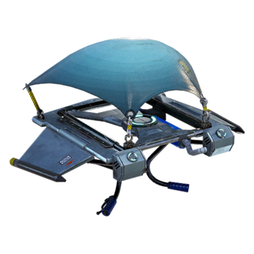
‘Emotes’: By far one of the most recognisable parts of the entire game, emotes are a great way to express yourself on the battlefield in a large variety of different ways.
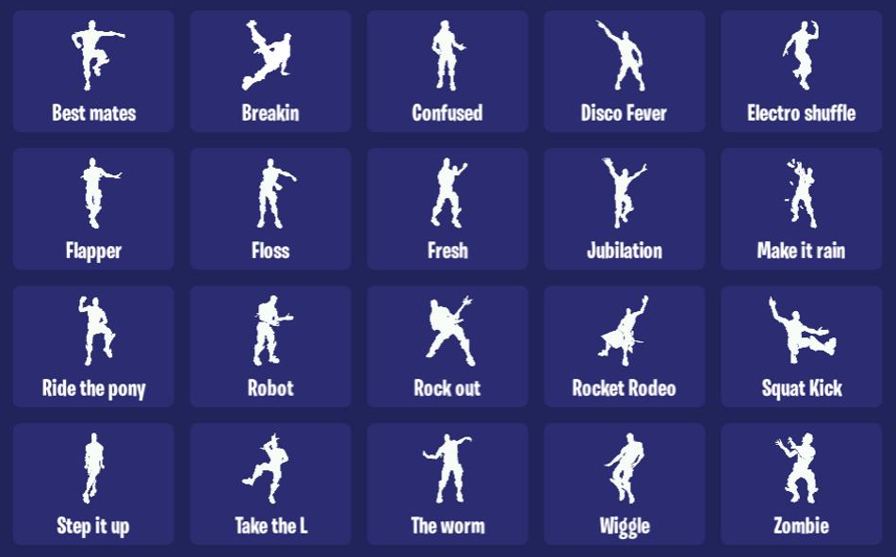
‘Weapon Wraps’: Similar to other games, weapon wraps give your weapons a unique look in many different ways. Some are also animated too!
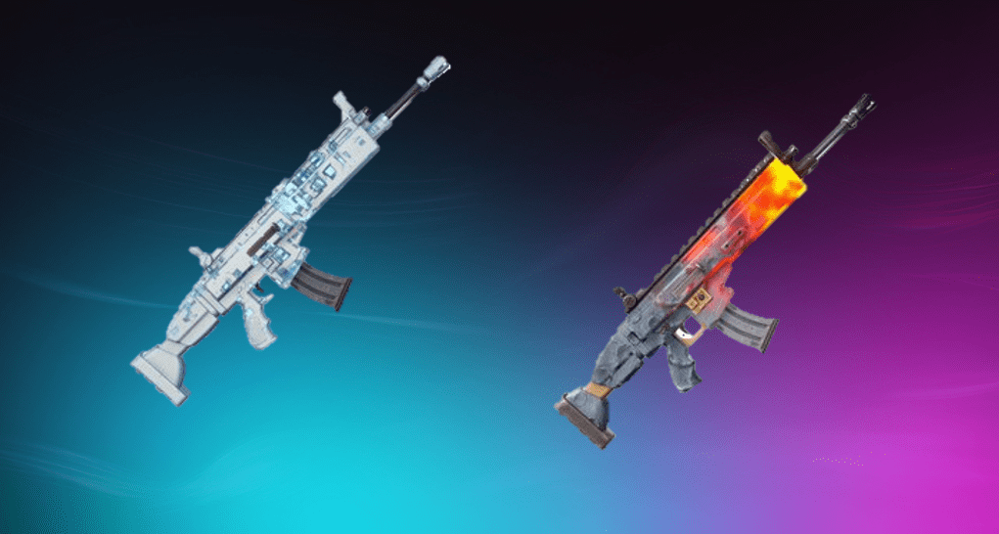
Note: All the items mentioned are purely cosmetic and do not give a competitive advantage during gameplay.
“How do I obtain these?” you may ask! Well, in come the ‘Item Shop’ and the ‘Battle Pass’. The ‘Item Shop’ is where the large majority of items can be purchased. Here’s everything you need to know about it!

- The Item Shop usually rotates every 24 hours (00:00 or 01:00 in the UK)
- Items can cost anywhere from 200 V-Bucks to 2000 V-Bucks (more on that later)
- Some items may be exclusive to promotions or other means and may never be obtainable again or for a long period of time
- Item Shops are completely random with their items
- Occasionally, there’s a community choice where players can vote between a selection of items. The one with the most votes will be featured in the Item Shop
- There is an option to ‘Support a Creator’ where if a player enters a valid creator code and purchases an item, that creator will receive roughly 5% of that purchase in ‘real world’ money (Certain products and events can bring up the percentage)
- After purchasing an item, players can cancel a purchase, which revokes the item from their locker and gives the V-Bucks back at no cost. However, this can only be done whilst still on the purchase screen or a little while afterwards
- Each account has three lifetime refund tickets. Any items purchased within the last thirty days can be refunded at the cost of one ticket. On certain occasions, Epic may give players who own a certain item a free refund at no cost e.g. if they’ve changed the look of an item due to community complaints
And that’s the Item Shop! Let’s move onto the Battle Pass!
Note: This segment is being written as of Chapter 2 Season 2, so please keep this in mind if you’re reading this at a later date, as mechanics for the Battle Pass could change drastically.
Fortnite Battle Royale runs on a seasonal schedule. Usually after around two and a half months, a new season begins. This is the time where the biggest changes to the game as a whole can happen such as introducing new POIS (Points Of Interest), items, new gameplay mechanics and of course a new Battle Pass.
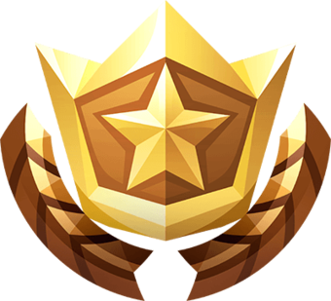
At the start of each season, every player begins at level 1 and the Battle Pass contains 100 levels that contain rewards. Some items can be earned for free; however paying 950 V-Bucks unlocks all the rewards up to the current level you’re at, and can obtain up to over one hundred rewards in total including (but not limited to) outfits, back blings, emotes, pickaxes, gliders and more.
Purchasing the Battle Pass also allows players to complete missions and extra challenges, which can reward players with XP (experience points) to level up alongside additional cosmetics.
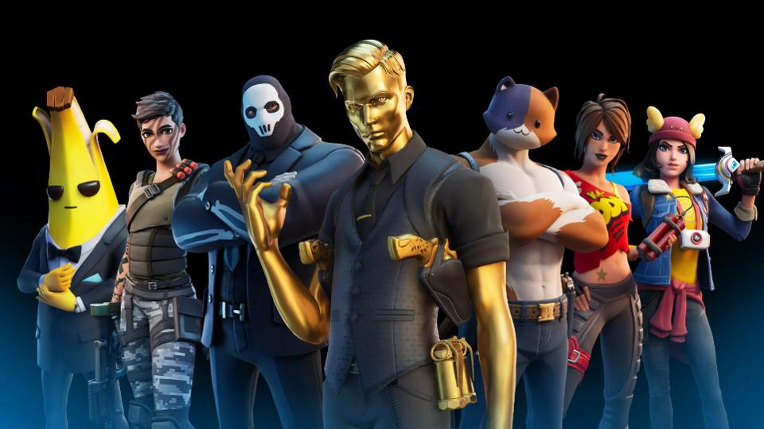

Players can also upgrade their level for 150 V-Bucks per level. Once the current season has ended, missions and challenges from that season cannot be completed and any cosmetics from the current Battle Pass will never be obtainable again.
After talking about these, it’s important to start mentioning V-Bucks.
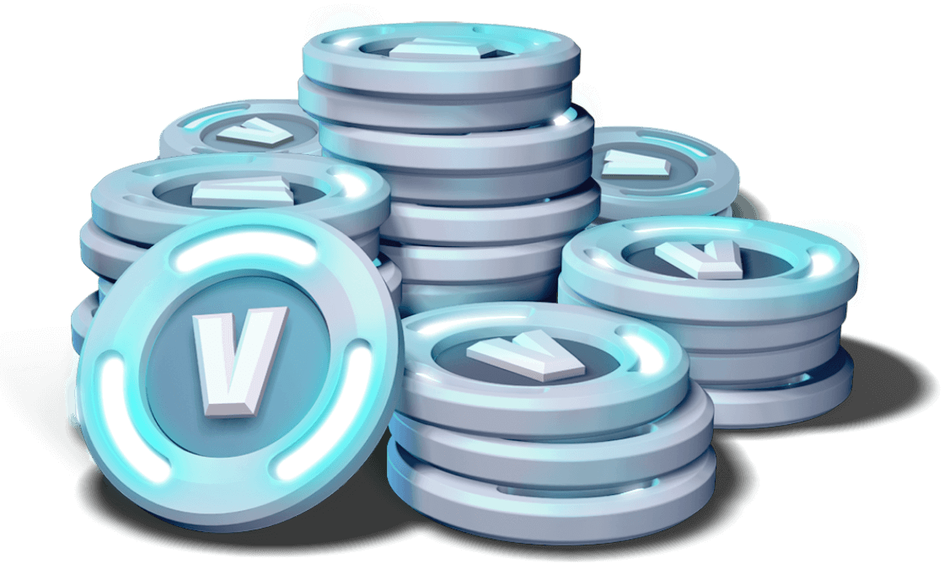
Here’s a list on how they work:
- V-Bucks are Fortnite Battle Royale’s virtual currency
- They can be only purchased from the in-game store, certain bundles and V-Bucks cards from trusted retailers
- V-Bucks purchased on one platform from the store cannot be transferred to other platforms
- V-Bucks can also be earned from the Battle Pass or certain quests from Fortnite Save The World. Once Fortnite Save The World leaves early access, those who will start playing after the period has ended will receive X-Ray tickets instead. This does not apply for those who purchased a founder’s pack before it’s ended.)
- Here’s the pricing for V-Bucks:
1,000 V-Bucks = £7.99
2,800 V-Bucks = £19.99
5,000 V-Bucks = £29.99
13,500 V-Bucks = £79.99

The online aspect of Fortnite Battle Royale is one of the most crucial parts to know about, considering there are a lot of features and quirks to go through.
Fortnite Battle Royale must always have access to an internet connection in order to be played and an account needs to be made, tailored to what system the game is being played on. The game can only be played on the latest patch available.
Fortnite Battle Royale also has a built in ‘Friends List’ that gives the player information on what their friends are doing in-game such as what game mode they’re playing, number of people are in their lobby and other information.
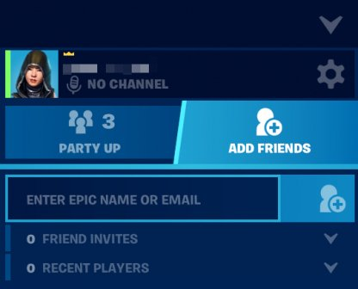
‘Friend Requests’ can also be from the Add Friends tab by typing a player’s username, but the receiving player must accept the request to be ‘in-game friends’.
During normal gameplay in Solo or Don’t Fill parties, the player won’t have any form of communication via voice chat or messaging. In ‘Duos’, ‘Squads’, ‘Team Rumble’ or other game modes, there is an ‘Option to Fill’ which puts players in parties with random players. During this, players have an opportunity to communicate via voice chat and can easily send friend requests. Once said player accepts the request, they can join your party, send messages, invite the player to their party and other quirks. ‘Clicking the Cog’ in the ‘Friends’ menu gives you extra options, such as toggling your status and party privacy.
On Fortnite Battle Royale Mobile, there is an exclusive feature known as the ‘Party Hub’.
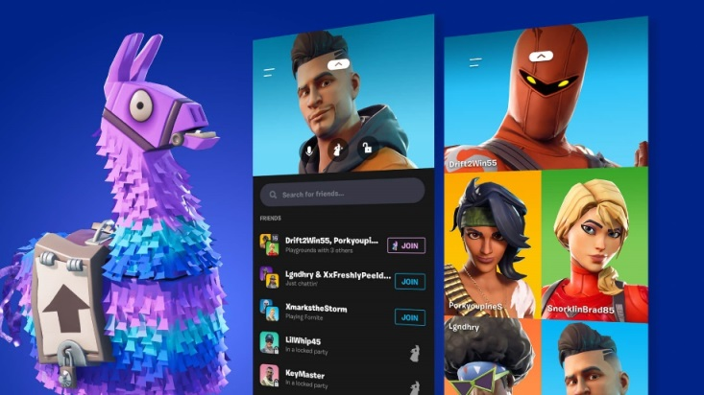

This feature allows players to select an icon for their account which mirrors their locker, invite their friends to parties, join parties and voice chat, preview the current Item Shop and of course launch the main game.
It’s worth noting that existing friends on a players account carries over between platforms and the party hub and when invited or one of their friends go online, a notification will pop up. These can be disabled in settings, or for specific friends by clicking on them and disabling the bell.
In Fortnite Battle Royale’s menu, there is an option for Parental Controls. After following the simple set up process, this will allow access to this menu for parents to control at their will.
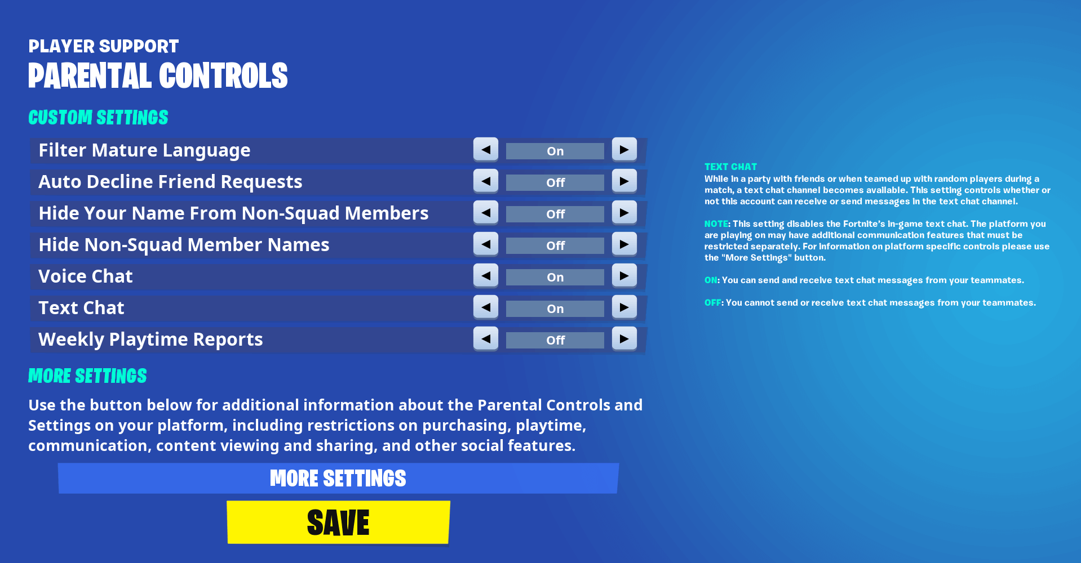
This menu allows change of several parts of an account’s online functionality, such as filtering mature language, disabling ‘in app’ purchases, content viewing and even receive weekly playtime reports sent directly to the email used during set up.
Fortnite Battle Royale has a massive online community throughout many different platforms such as Youtube, Twitch.tv, Mixer, Twitter and more.
However, as with many popular online communities, there is a fair share of misleading content known as ‘clickbait’.
Clickbait’s main premise is to mislead users into watching content that is simply untrue and which is used by content creators to gain more traction. The usual practice for clickbait is making a thumbnail in some form like this:

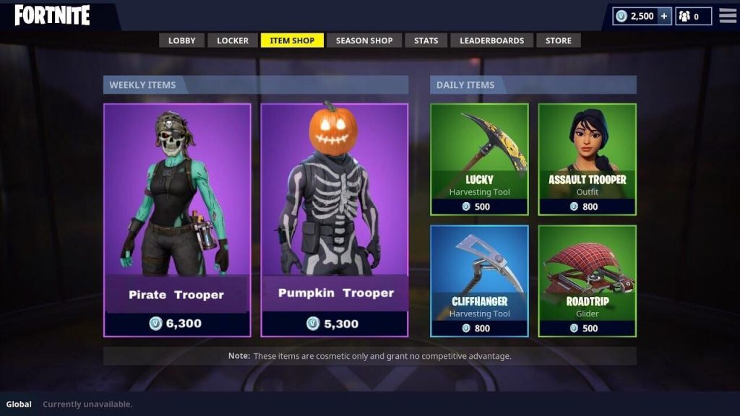

Clickbait then constantly asks the user to subscribe, like and comment whilst talking about unrelated content or going further to fake it.
Official Fortnite Battle Royale news will always be posted first on its official Twitter @FortniteGame, its website at epicgames.com and other official platforms.
And that’s all! If you’d like to play with me on Fortnite Battle Royale, please let me know first then I’ll give you my username.

Next time we will be delving into the deep and strange world of the Fortnite Battle Royale storyline!

