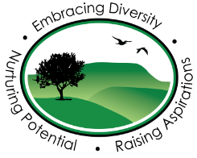
Pendle Community High School & College
I’m learning about social distancing

Social distancing means not getting too close to other people.
It means keeping a safe distance between me and anyone who doesn’t live in my house and is important when I go back to school.
Staff at school will let me know what the safe distance is.
This is really important at the moment to help stop a nasty virus called coronavirus.
It will help to stop the virus spreading from person to person and to keep us all safe.
It is also really important to wash our hands properly because this helps to stop viruses from spreading too. We can sing happy birthday twice while we do this - it can be fun!
I will have to wash my hands more often and at different times
- I will have to wash my hands when I arrive at school
- I will have to wash my hands before I touch food
- I will have to wash my hands before I eat food
- I will have to wash my hands when I cough or sneeze. I need to use a tissue to catch the cough or sneeze, throw away the tissue in a bin and then wash my hands
- I will have to wash my hands if I touch my face
- I will have to wash my hands after going to the toilet
- I will have to wash my hands when I get home from school

