Boiled Eggs

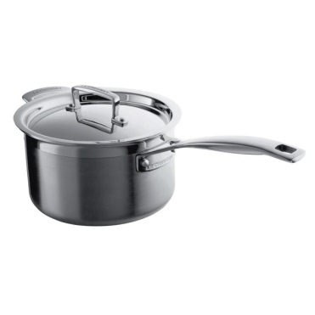
Fill a saucepan half full of water
Put a pinch of salt in
Put on the lid
Bring to the boil
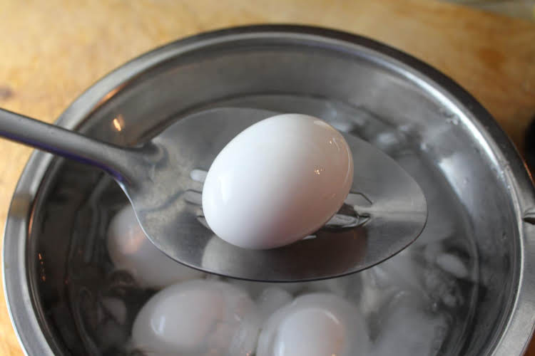
Carefully lower the eggs into the boiling water

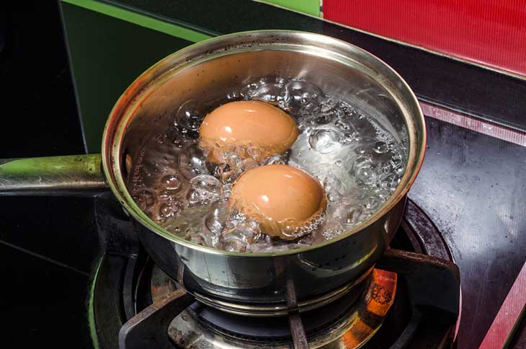
For dippy egg: 6 mins
For hard boiled: 8 mins

Serve with toasted soldiers

