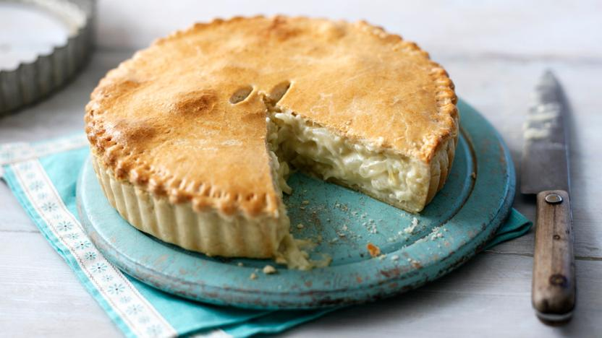
Cheese and Onion Pie
Ingredients

Filling:
1 medium potato peeled and cubed
2 white onions finely chopped
50ml whole milk
50ml double cream
150g Cheddar cheese grated
1 tbsp plain flour
½ tsp English mustard
Salt & pepper

Method:
- Line a pie dish with short pastry and roll enough for the lid
- Boil the potato cubes until soft, drain
- Fry the onions over a low heat in a little oil until soft
- Add the flour and make a roux
- Add in the cream and milk and bring to simmer stirring until the mixture thickens
- Take off the heat, add in the mustard potatoes and cheese
- Carefully mix until combined allow to cool
- Blind bake the pie base until pastry is pale
- Take out and add the filling
- Fix the lid on with brushed egg wash around the edge
- Brush egg wash on the lid and cut in a vent
- Bake at 180°C for 20-25 minutes or until the pie is golden brown

