Pizza Name: Mozzarella, Fresh Tomato and basil
For the dough follow the separate recipe.
A video of how to Knock back and knead the dough is on the T drive
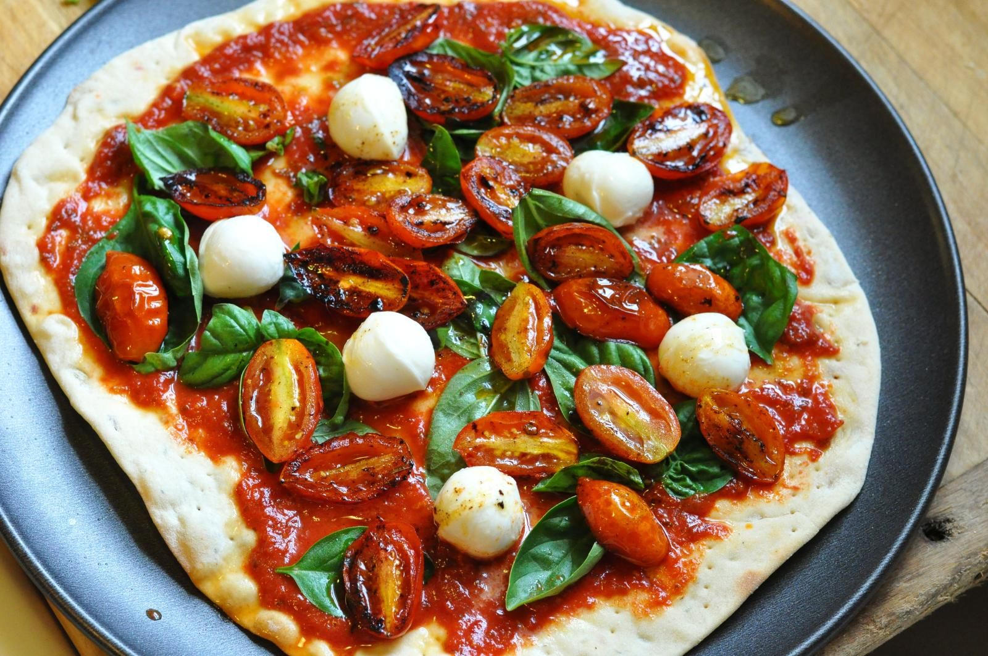

Ingredients per pizza:
100g Mozzarella pinched into small chunks
8 fresh baby tomatoes cut in half
Handful of fresh basil roughly chopped
1 cup of tomato base mix (passata)

Method:

- Roll out the proved and knocked back pizza dough onto a 12” pizza tray
- With a ladle spread the passata evenly leaving a finger with at the edge
- Spread the Mozzarella evenly over the passata
- Arrange the tomatoes seed side up evenly over the pizza
- Sprinkle the fresh basil
- Cook at 271°C for 3 ½ minutes
- Cut into 8 pieces with a pizza wheel on a chopping board
- Serve straight away

