Pizza Name: Garlic and Cheese
For the dough follow the separate recipe.
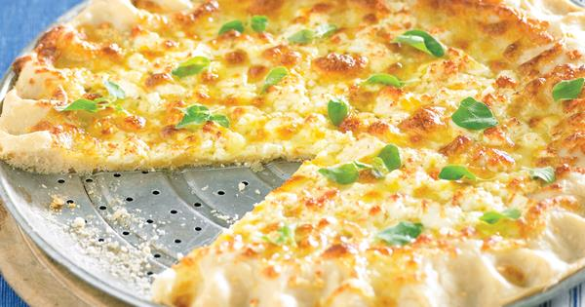
A video of how to Knock back and knead the dough is on the T drive

Ingredients per pizza:
100g fresh white cheese grated
Handful of fresh rosemary
1tsp sea salt
1 cup Ricotta cream (see separate recipe)

Method:

- Roll out the proved and knocked back pizza dough onto a 12” pizza tray
- With a ladle spread the Ricotta cream evenly leaving a finger with at the edge
- Spread the grated white cheese evenly over the passata
- Sprinkle the fresh rosemary
- Sprinkle the sea salt evenly
- Cook at 271°C for 3 ½ minutes
- Cut into 8 pieces with a pizza wheel on a chopping board
- Serve straight away

