Scrambled eggs on toast

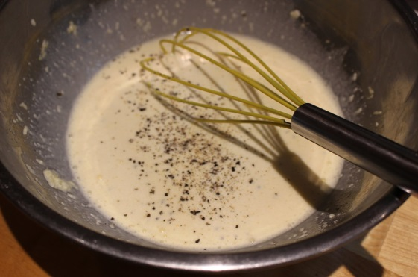
Whisk 2 eggs per person with a splash of milk and salt and pepper

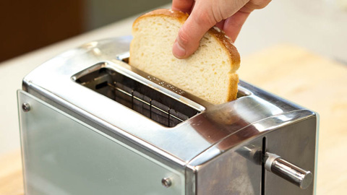
Put a piece of toast into the toaster and toast until golden brown

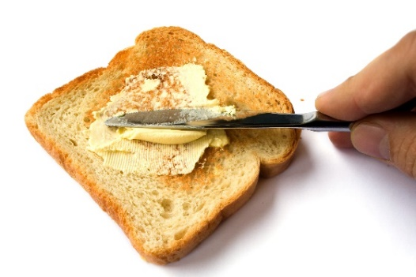
Spread butter on the toast

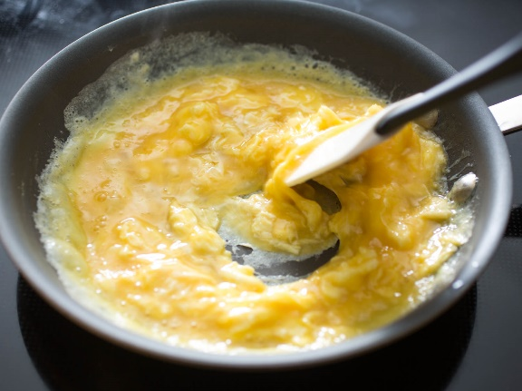
Heat a little oil or butter in a pan until very hot and pour the egg mix in
Take off the heat and stir until cooked

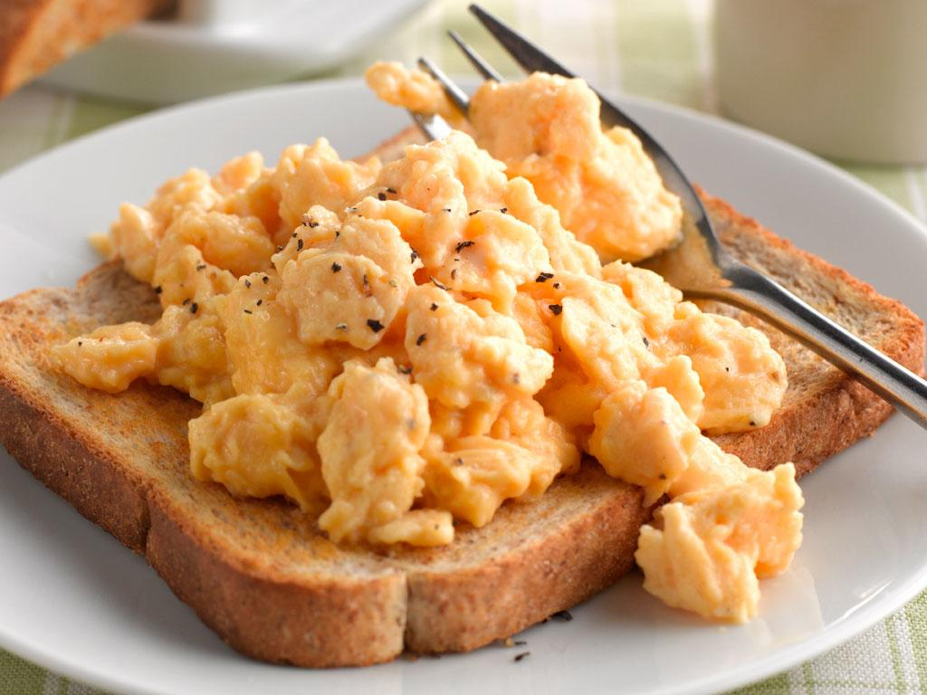

Serve and eat straight away

