Cheese Blintzes Recipe
For the Pancakes:
1 ¼ milk
2 eggs
½ cup plain flour.
Blend all until smooth and sieve.
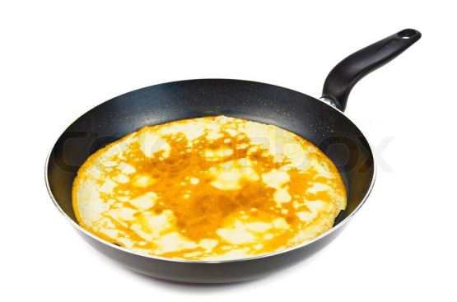
Fry at high heat. These can be done before hand, or a TA can be doing them whilst filling is prepared.

For the Filling:
2 packs cream cheese
1/4 cup sugar
1 egg yolk
2 tsp fresh lemon juice
1 tsp vanilla

Place all ingredients in a bowl
Using a wooden spoon, mix thoroughly together

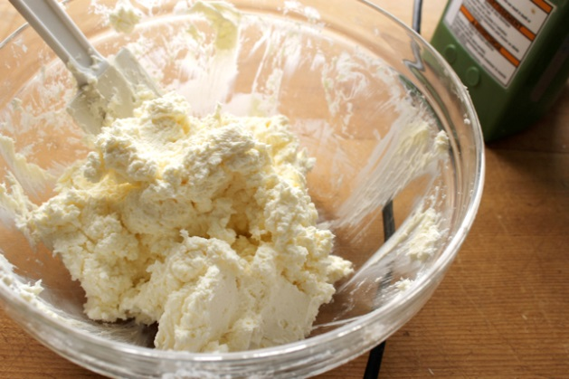

Place a spoonful of mix in the middle of a pancake and fold over –

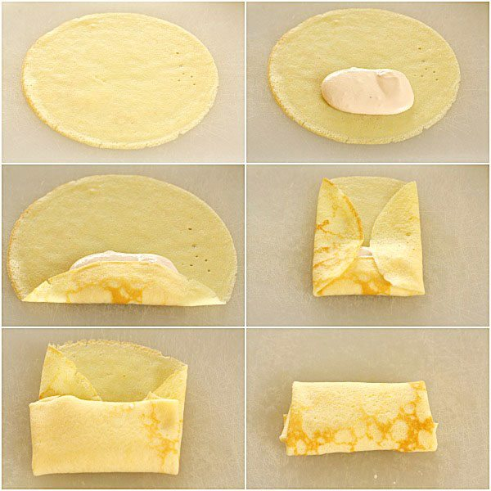

Fry on a high heat for 2-3 minutes
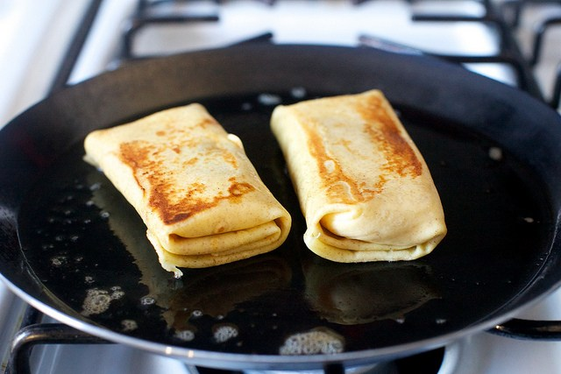

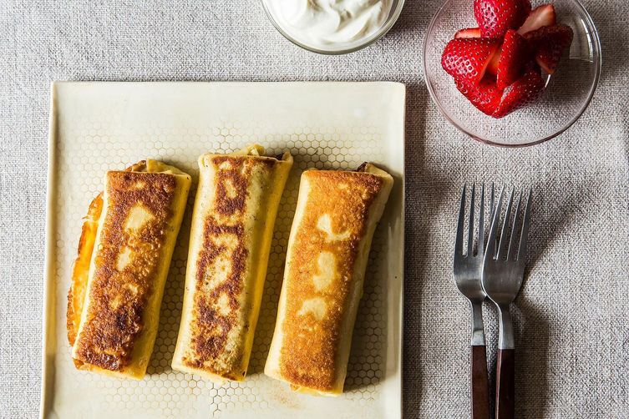
Serve and enjoy

