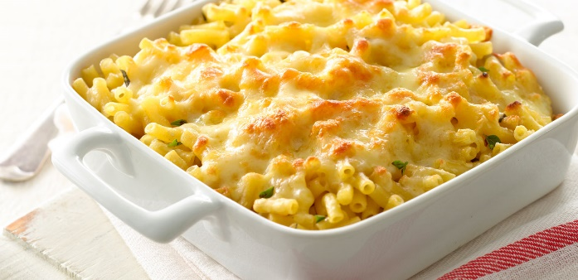
Macaroni Cheese
Ingredients
250g macaroni
40g butter
40g plain flour
600ml milk
200g cheese
50g fine grated cheese

Method:
Cook the macaroni for 8-10 minutes, drain well and set aside
With the flour, butter and milk, create a basic white sauce (see separate recipe)
Stir in half of the cheese until melted
Add the macaroni and carefully combine all ingredients
Transfer to an oven proof dish, sprinkle with the remaining cheese and finely grated cheese
Place under a hot grill until cheese is browned and bubbling
Serve straight away

