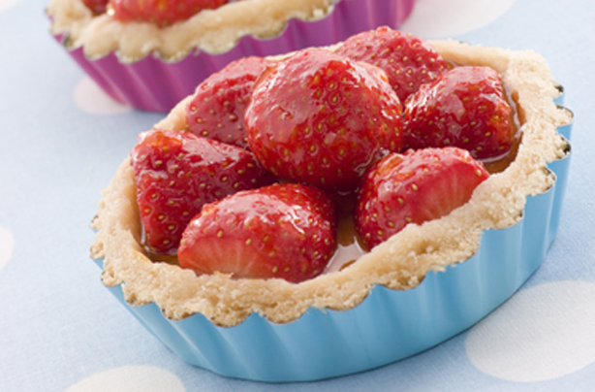
Strawberry Tarts
Makes 12
2 punnets of fresh strawberries
100g strawberry jam for glaze
Egg wash for glazing tart cases

Ingredients for the Pastry Cream:
500ml whole milk
100g caster sugar
1 tsp vanilla extract
4 large free range eggs
40g cornflour

Method:
- Heat the milk and vanilla until a simmer
- Whisk eggs, sugar and cornflour together until pale
- Pour a little milk into the egg mix and whisk until combined
- Add back into the pan of milk and whisk continuously over a low heat until thick

For the pastry:
- Roll out the sweet pastry to about 2mm thick
- Mould into an individual tart case and carefully press up the sides so they stand proud of the rim of the tart case
- Prick the bottom with a fork
- Bake blind at 140°C until pale
- Glaze with egg wash and return to the oven to cook until golden brown
- Allow to cool on a cooling wire
- Pipe in the pastry cream half way up the tart case
- Hull, wash and halve fresh strawberries and arrange on top of the pastry cream
- Glaze with hot strawberry jam
- Chill for at least 30 minutes and serve

