Farfalle Pasta Salad Ingredients for 4 people
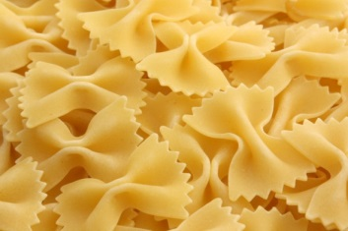
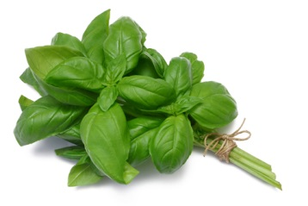
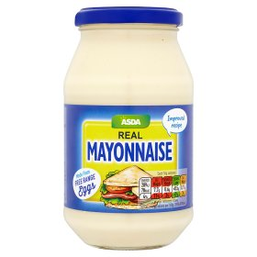
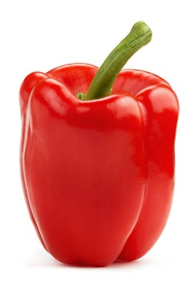
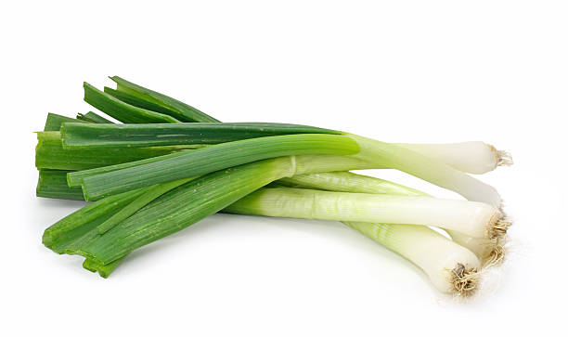
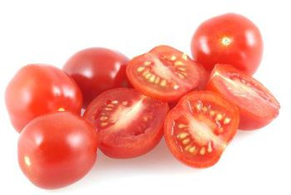
400g farfalle pasta

100g cherry tomatoes

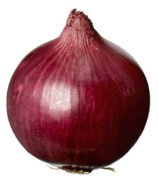
Half a red onion

4 spring onions

1 red pepper

Mayonnaise to bind

Herbs and spices
Farfalle Pasta Salad Ingredients for 4 people
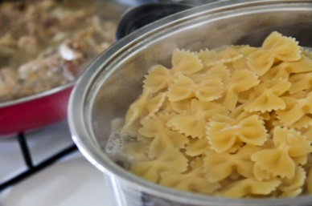
Cook the farfalle pasta in boiling water with a little oil until ‘al dente’
Half the cherry tomatoes
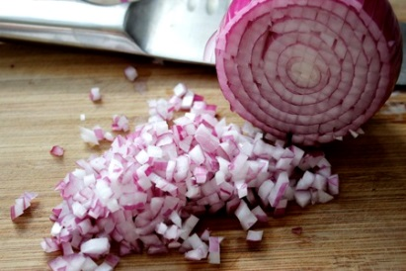
Finely dice the onion
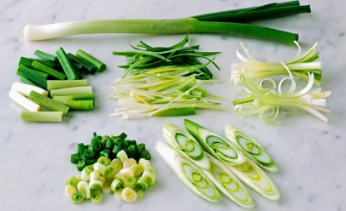

Slice or dice the spring onion

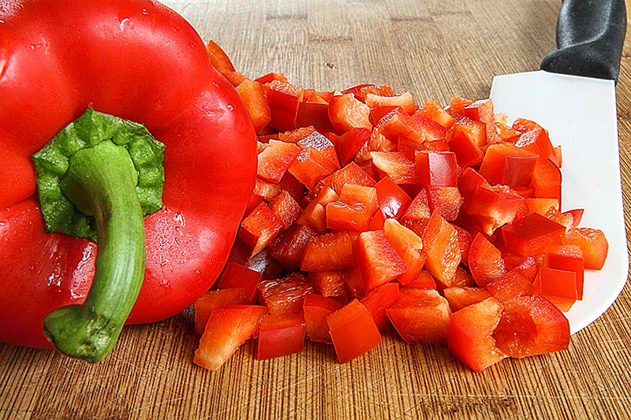

Finely dice the red pepper
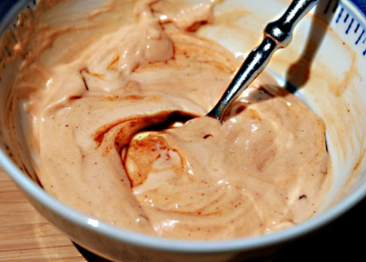
Mix spices and herbs into the mayonnaise to taste

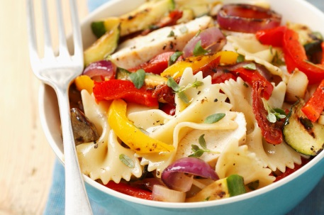
Divide between 4 bowls and enjoy

