Poaching Eggs
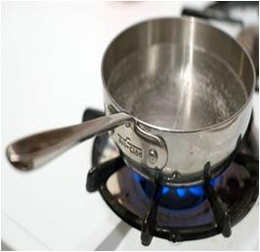

Bring a pan of water to the boil.

Add a few splashes of vinegar

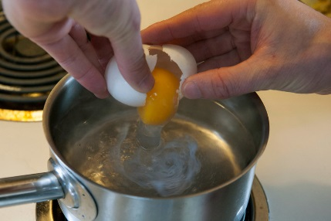

Carefully break the egg into the water.
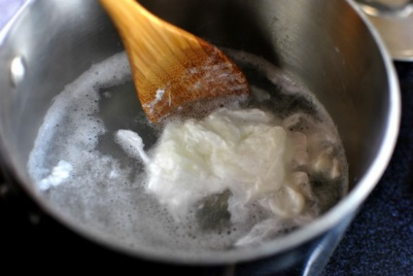
Gently keep swirling the water to help the egg white stay together.

Serve with black pepper and enjoy!

