**Ragu Sauce**

**For 2 portions**

[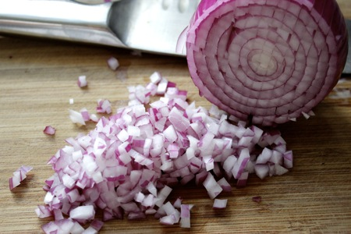](http://www.google.com/url?sa=i&rct=j&q=&esrc=s&source=images&cd=&ved=&url=http://tastewiththeeyes.com/2011/09/patriotic-potato-salad-trifle/&psig=AOvVaw1lAfcTbtSPODbZjXWIfqdm&ust=1512488784665971)

Chop the onion

[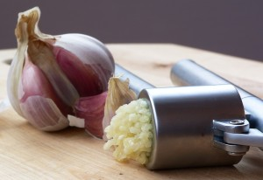](https://www.google.com/url?sa=i&rct=j&q=&esrc=s&source=images&cd=&cad=rja&uact=8&ved=0ahUKEwjJuvD_3vDXAhXC7xQKHeszB8sQjRwIBw&url=https://www.mmmgarlic.com/crush-garlic/&psig=AOvVaw3yH-2EHVzW1VMXAsAa4U0V&ust=1512490141220770)

Crush the garlic

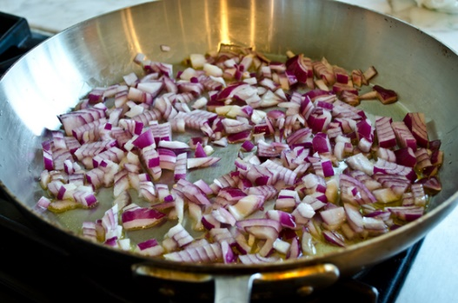

Fry the onions and the garlic

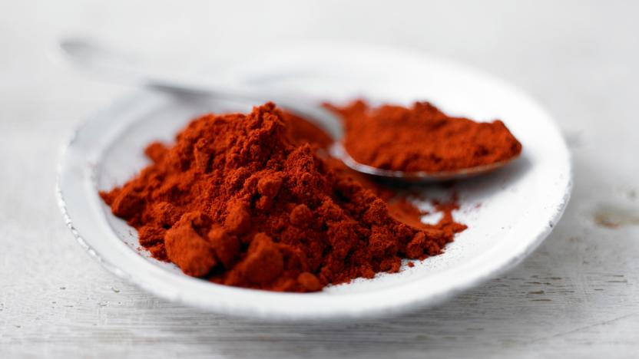

Sprinkle in the paprika

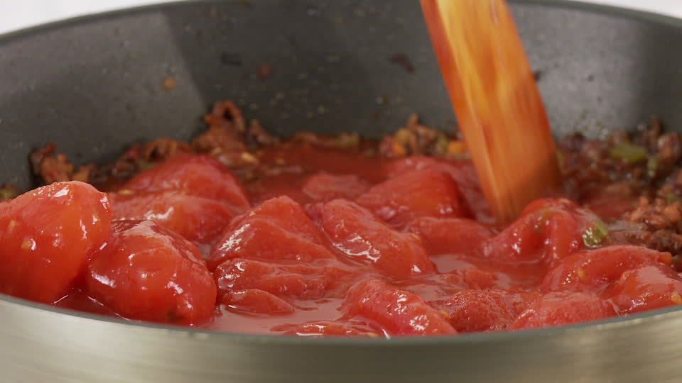

Stir in the chopped tomatoes

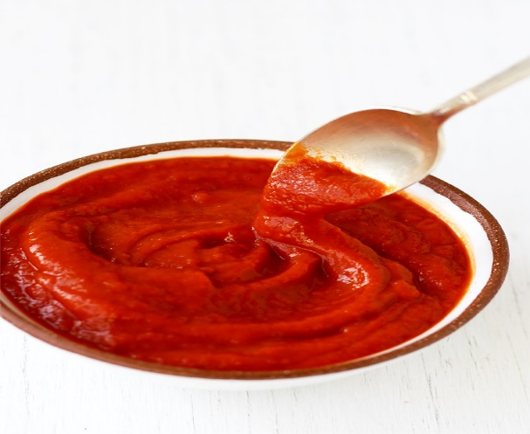

Add the tomato puree

[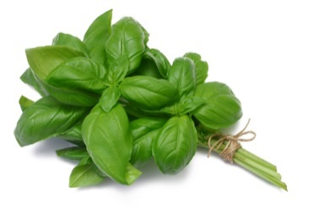](http://www.google.com/url?sa=i&rct=j&q=&esrc=s&source=images&cd=&cad=rja&uact=8&ved=2ahUKEwjLrvO4scvZAhXqL8AKHd73BUYQjRx6BAgAEAY&url=http://www.agriprohub.com/product/fresh-basil/&psig=AOvVaw2jR_oBn2zg3GL2mQL3hr9t&ust=1520002694703845)

Add the fresh basil