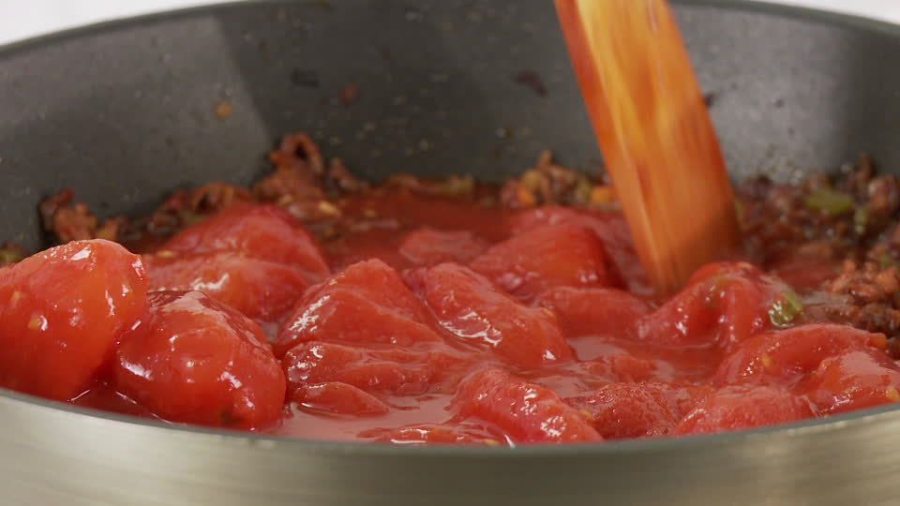
Ragu Sauce
For 2 portions

Ingredients:
1 red onion chopped
1 clove garlic crushed
1 tbsp tomato puree
1 tin chopped tomatoes
Fresh basil
Salt, pepper, paprika

Method:
- In a saucepan fry the onions until soft
- Add the garlic cook for 2 minutes
- Add 1 tsp paprika and cook through
- Add tomato puree and cook through
- Add chopped tomatoes and simmer until cooked
- Taste and season with salt and cracked black pepper

