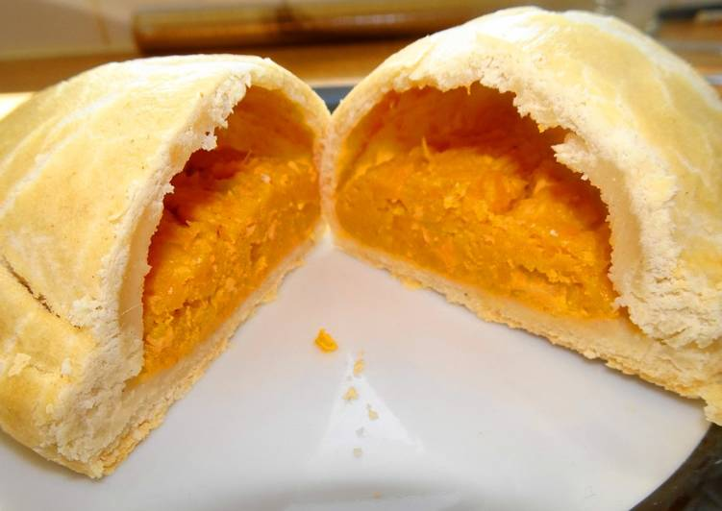
Sweet Potato Pasties
Makes 12 pasties
Ingredients:
6 large sweet potatoes
4 red onions finely chopped
2 garlic cloves crushed
Salt and cracked black pepper

Method:
- Prick the skins of the potatoes and rub with olive oil
- Bake at 180° for 60 minutes or until soft (This can be done the day before)
- Peel skin off and mash
- Fry the red onions in a little oil over low heat until soft
- Add in the garlic and cook through
- Mix into the potato and season
- Roll out the short pastry big enough for the pasty crimps
- Use crimps to create pasty
- Glaze with egg wash
- Bake on a greased and floured baking tray at 160°C for 20-25 minutes or until golden brown

