Vegetable Paella
Ingredients
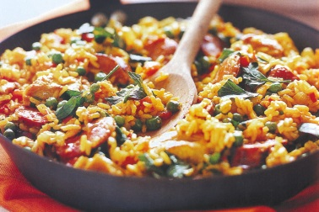
- 2 cloves of garlic
- 1 onion
- 1 carrot
- ½ a bunch of fresh flat-leaf parsley
- olive oil
- 1 teaspoon sweet smoked paprika
- 1 red pepper
- 1 tablespoon tomato purée
- 1 organic chicken stock cube
- 300 g paella rice
- 100 g frozen peas
Method
- Peel and finely slice the garlic, peel and roughly chop the onion and carrot. Finely chop the parsley stalks.
- Put a glug of oil into a large lidded shallow casserole or paella pan on a medium heat, add the garlic, onion, carrot, parsley stalks and paprika, and fry for around 5 minutes, stirring regularly.
- Deseed and chop the pepper, then add to the pan for a further 5 minutes.
- Stir through the tomato purée and crumble in the stock cube, then add the rice and stir for a couple of minutes.
- Pour in 750ml of boiling water and add a pinch of sea salt and black pepper. Pop the lid on and bring to the boil, then reduce to a simmer for 15 minutes, stirring regularly from the outside in and from the inside out, and adding a splash of water if needed.
- Stir in the peas, replace the lid, and cook for a further 5 minutes, or until hot through.
- Season to perfection, then chop the parsley leaves, scatter them over the paella.
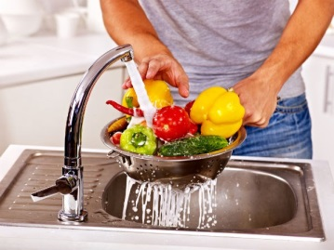

Wash the vegetables

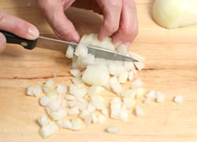
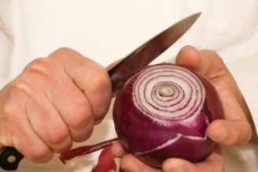
Peel and chop the vegetables

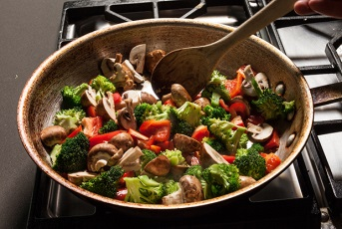
Stir fry the vegetables

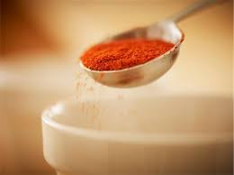
Add the spices you want

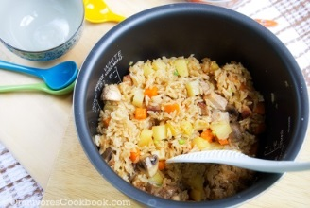
Add the rice and water and bring to the boil, then simmer for 15 minutes.

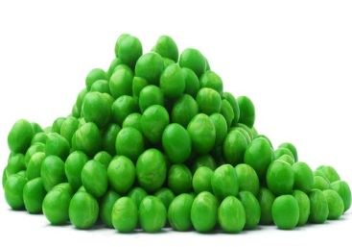

Add the peas and cook for a further 5 minutes.

Eat and enjoy

