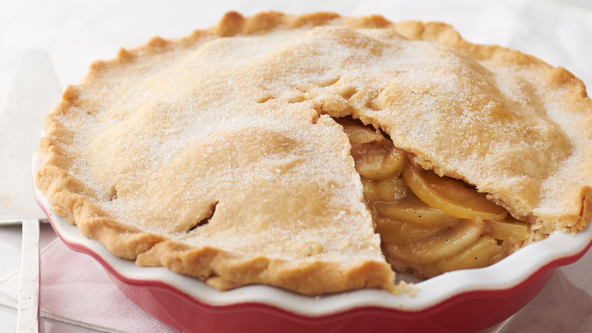
Apple Pie
Makes 1 pie
Ingredients:
1 kg cooking apples
100g sugar
1 tsp cinnamon
1 tsp vanilla extract
100ml water
Egg wash

Method:
- Peel, core and cut apples into large chunks
- Put into a large pan with the sugar, cinnamon, vanilla and water and over a low heat cook the apples down until slightly soft
- Place in a sieve and allow to cool and any access liquid drain
- Line a pie dish with sweet pastry and prick the base with a fork
- Spoon in the mixture
- Add and crimp the lid and glaze
- Sprinkle top with sugar and bake at 200°C for 45-50 minutes or until golden brown
- Serve with cream, custard or ice cream

