**Fresh Egg Pasta**

[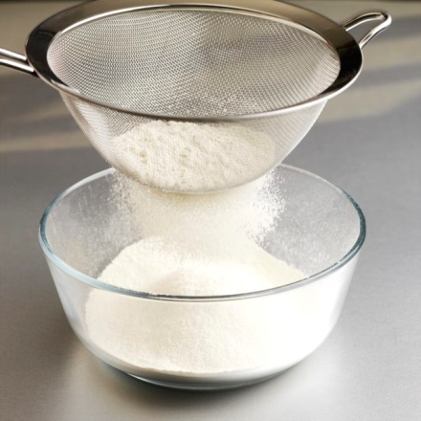](https://www.google.com/url?sa=i&rct=j&q=&esrc=s&source=images&cd=&cad=rja&uact=8&ved=0ahUKEwiOls3ojvjXAhVIxxQKHYsqBOAQjRwIBw&url=https://www.leaf.tv/articles/what-is-the-difference-between-sieving-sifting/&psig=AOvVaw39h-DWUGkclVh75VgPH-oR&ust=1512743480283805)

Sieve the flour

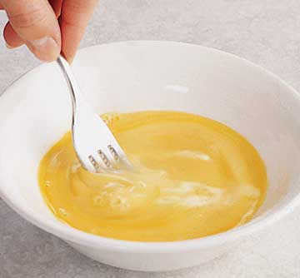

Beat the egg

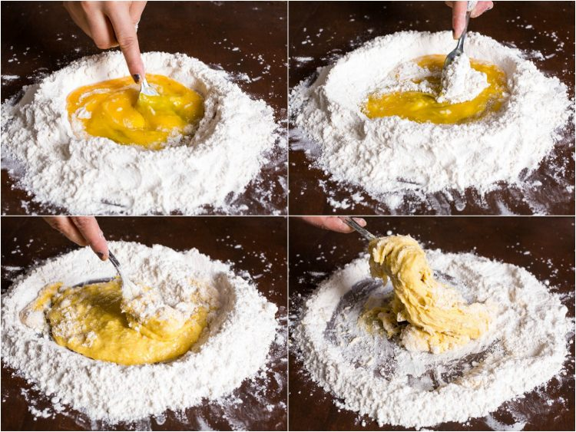Then: