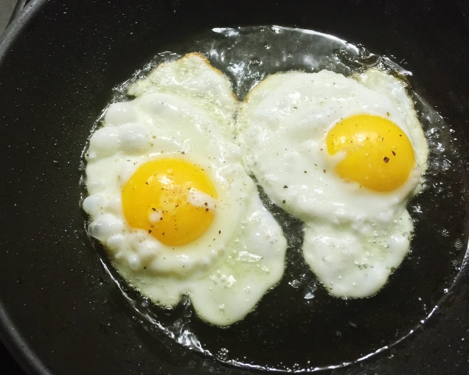
Frying Eggs

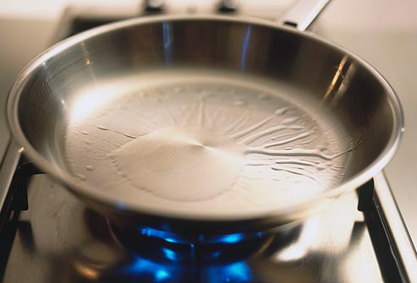
Heat a little oil in a frying pan

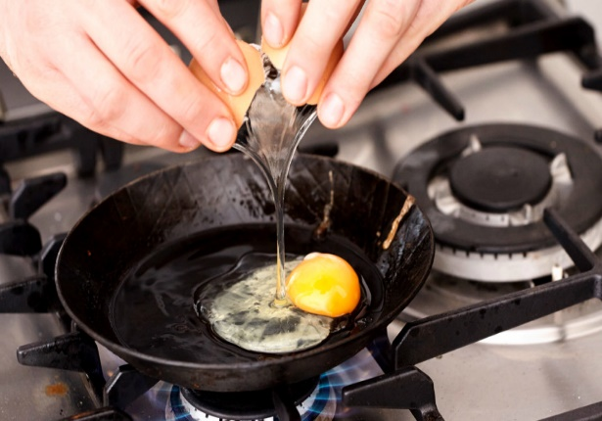
Carefully crack an egg into the pan and cook until the outside turns white and the yolk is set

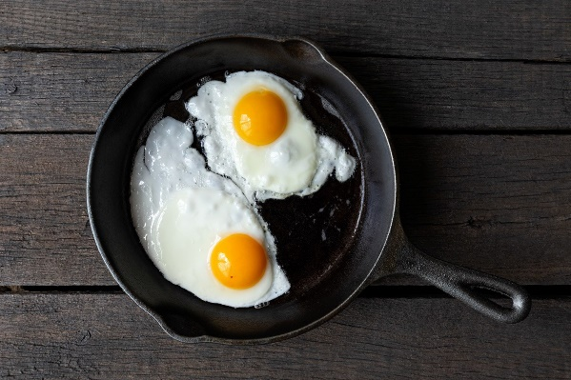

Once cooked, enjoy

