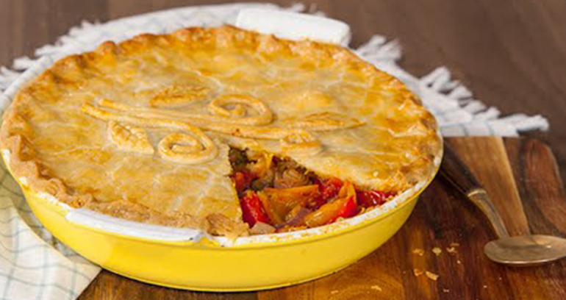
Vegetable Pie
Make 1 pie for 4 people

Ingredients:
½ head broccoli cut into florets
½ cauliflower cut into florets
1 white onion finely chopped
1 celery stick peeled and sliced
2 carrots peeled and finely sliced
2 tbsp chopped fresh parsley
4 tbsp veg stock
300ml whole milk
2 tbsp plain flour

Method

- Blanch the broccoli and cauliflower for 3 minutes in boiling, salted water. Refresh
- In a little olive oil, cook the onion over low heat until soft, add the celery and carrots and cook for 5 minutes
- Stir in the flour and make a roux
- Whisk in the stock and milk and bring to the boil, simmer, stirring continuously until mixture thickens
- Stir in the parsley and season
- Stir in the broccoli and cauliflower and allow to cool slightly
- Spoon into a pie dish lined with rough puff pastry
- Add and crimp the lid
- Bake at 200° for 30 minutes or until golden brown

