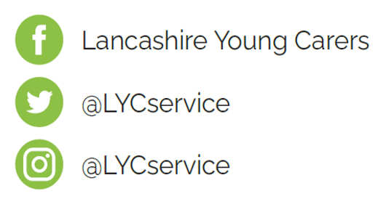**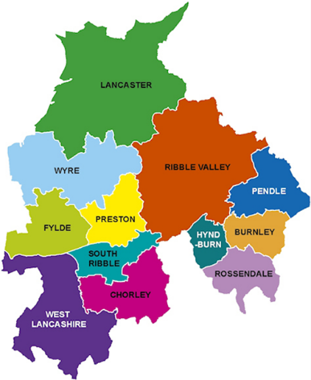

**Lancashire Young Carers**

**We support young carers under the age of 18 who provide regular and ongoing care and emotional support to a family member who is physically or mentally ill, disabled, or misuses substances and are significantly affected by their caring role. Our young carers have a named worker who stays with them from the first point of contact, initial assessment, support and reviews. We offer one to one’s to offer support around their caring role; we support them to access services; support them to take control of their decisions and meet them where they feel comfortable to talk.**

**We are committed to working with all young carers across Lancashire. Our aim is to assess, support, empower and equip young carers by ensuring they are recognised as a young carer, supported to have a life outside of their caring role, provide skills to improve their wellbeing and reduce the negative impact their caring role has on them.**

**We accept referrals from all organisations, services, schools, training providers, health, social care, and self or family referrals. Every young carer has a right to an assessment, which considers the level of caring role and the impact this has on their daily life. The assessment will enable the young carer to identify any areas of need and support.**

For more information you can scan the QR code above or contact us on:

**Tel: 01772 641002**

**Email:** [**lancashireyoungcarers@barnardos.org.uk**](mailto:lancashireyoungcarers@barnardos.org.uk)