PENDLE COMMUNITY
HIGH SCHOOL & COLLEGE
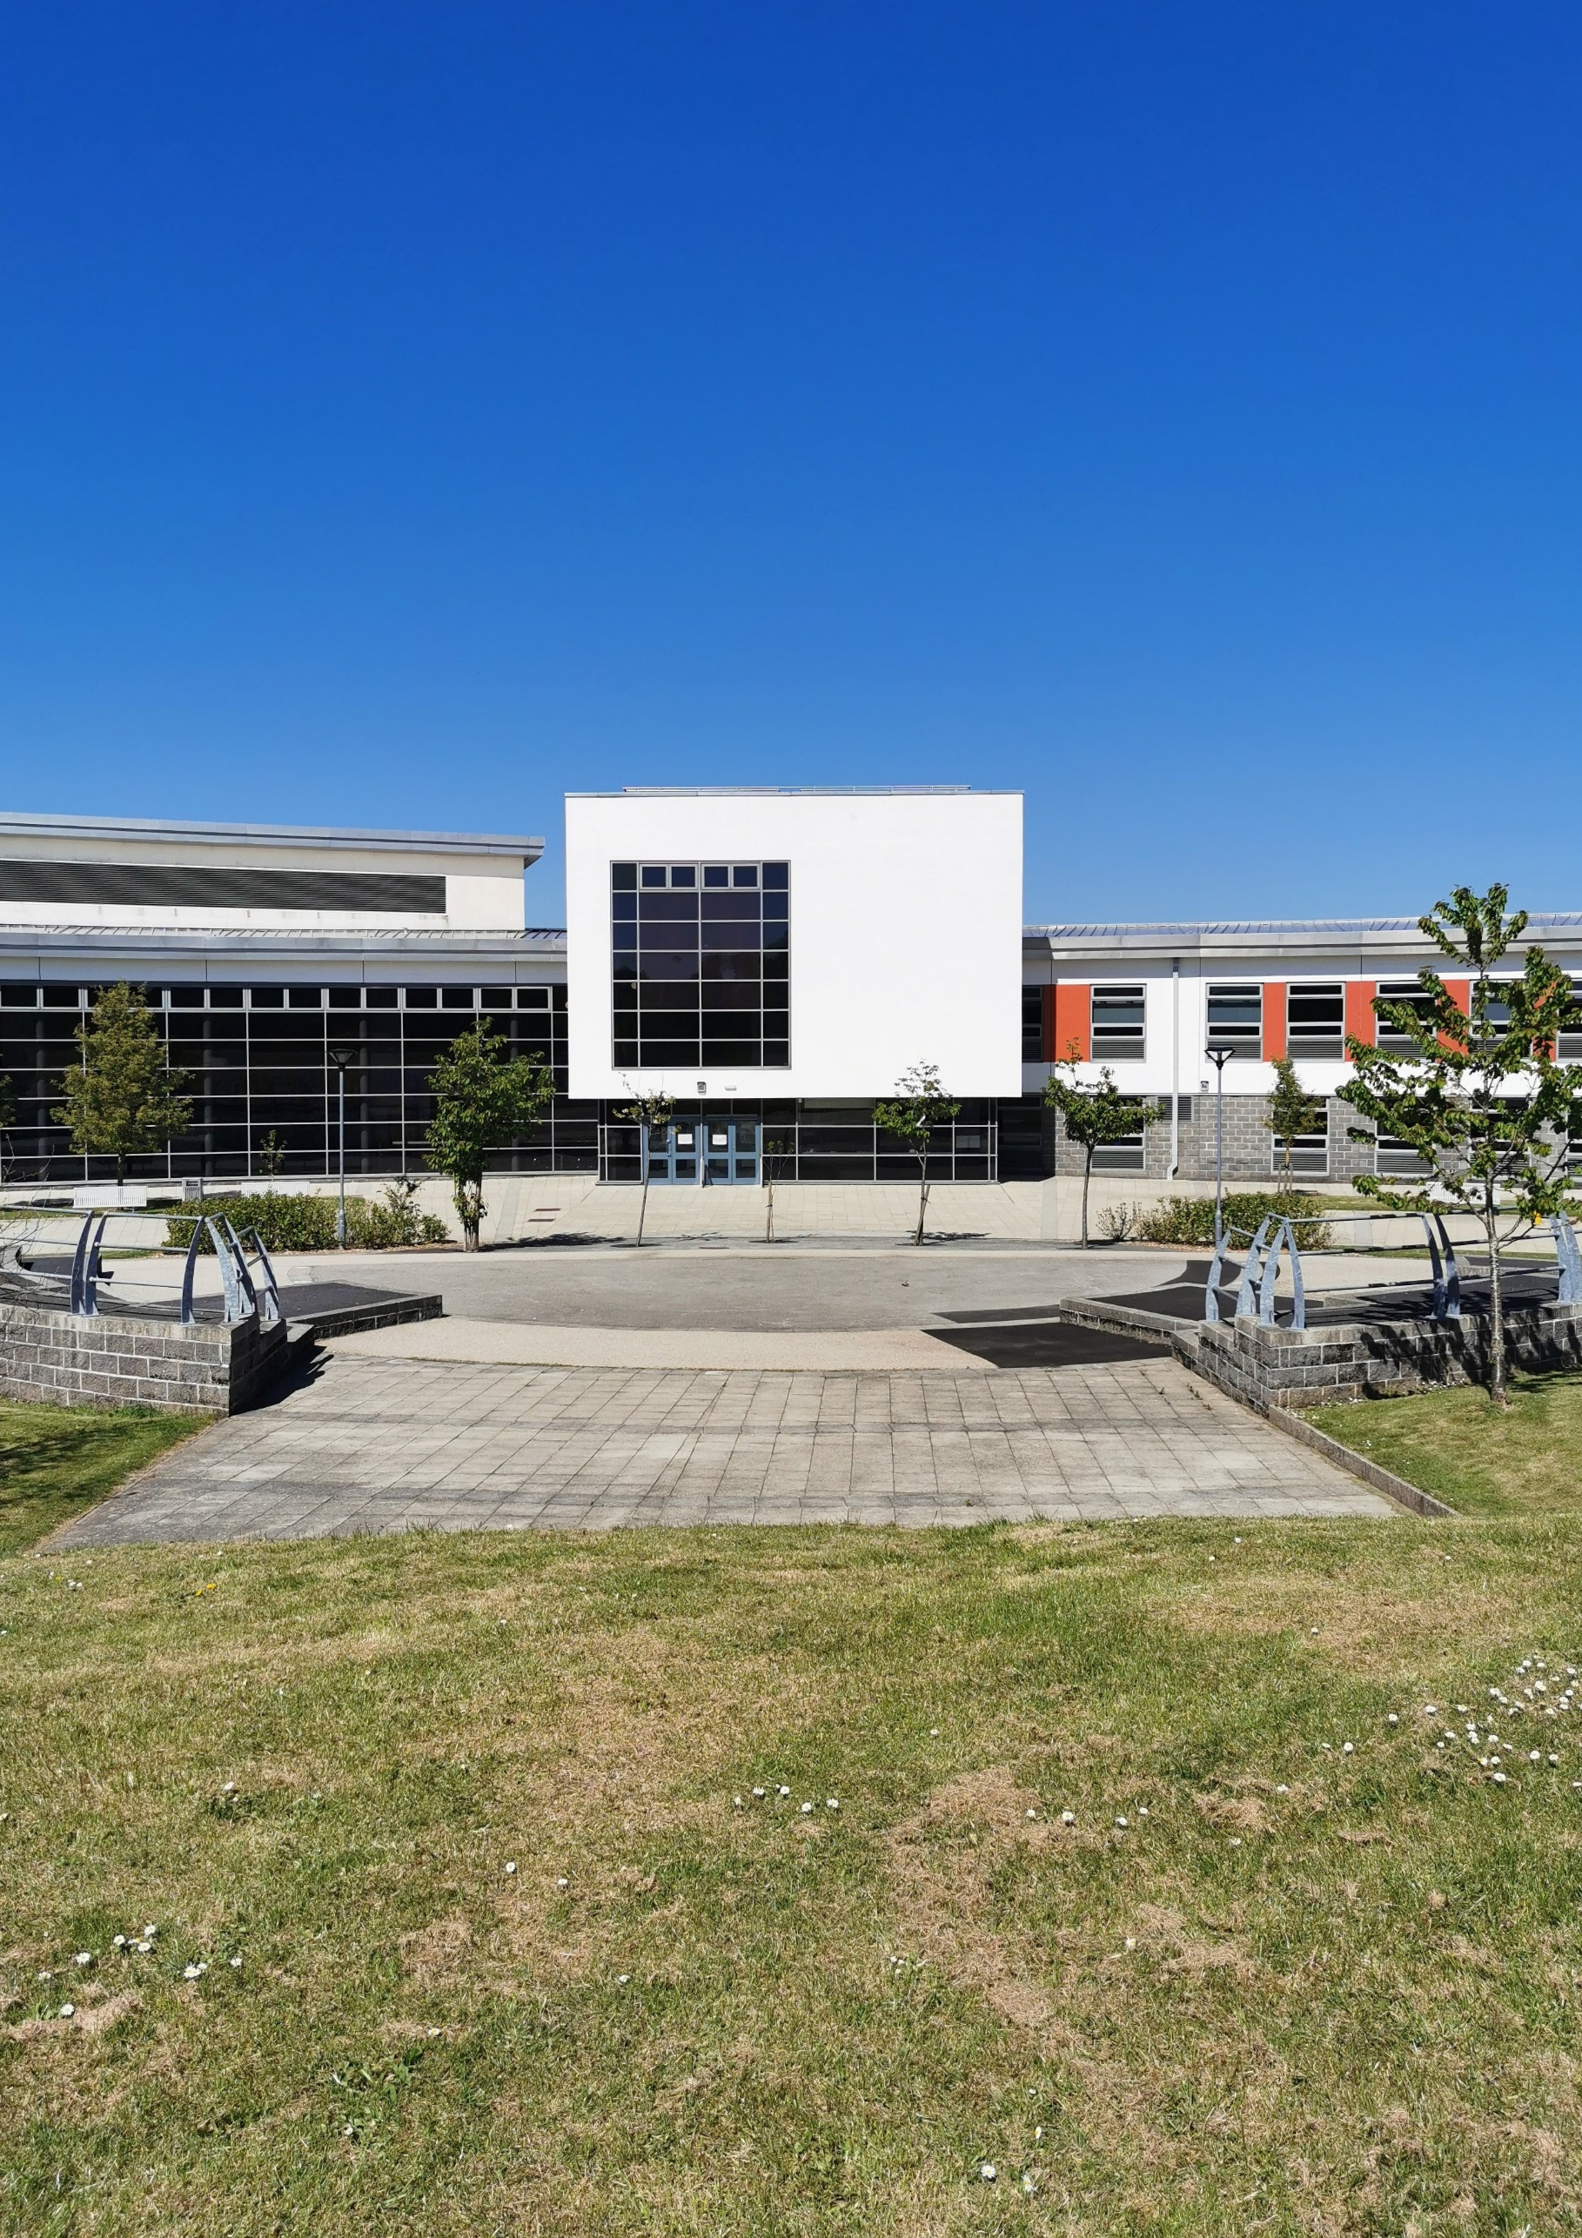


APPLICATION PACK

WWW.PCHS.LANCS.SCH.UK
APPLICATION PACK – SCHOOL BUSINESS SUPPORT OFFICER 1

Pendle Community High School and College (PCHS&C) is an outstanding community special school for students with generic learning difficulties. We currently have 165 students on roll (ages 11 -19), with a variety of special educational needs including autistic spectrum disorders, speech, language and communication needs, and physical, medical and/or sensory needs.
PCHS&C moved into our purpose-built accommodation in 2008, where it is co-located with a mainstream secondary school. Our school and college provide an exciting and enriching environment, with a range of opportunities for social and educational inclusion.

Dear Candidate,

Thank you for requesting more information about the vacancy of School Business Support Officer at Pendle Community High School & College (PCHSC). At PCHSC our core values are at the HEART of everything we do:

- Honesty
- Embrace diversity
- Ambition
- Respect
- Togetherness

We are delighted that you have shown an interest in joining our thriving community. If you decide to pursue your application and are successful in securing a job with us, you will be joining a highly committed and dynamic staff team who all play a part in making a real difference to the lives of families, carers and young people with special educational needs.

In addition to this, we also offer a number of staff benefits which includes but is not limited to:

- Enrolment into the Local Government Pension Scheme
- Access to Employee Assistance Program
- Free use of our on-site gym
- Free on-site parking
- Access to the National College and regular CPD opportunities
- Term time only working (pay pro rata to reflect this)

For more information about our school & college, please visit our website www.pchs.lancs.sch.uk.

The post you are applying for is covered by the Rehabilitation of Offenders (Exceptions) Act 1975. If successful, you will be required to apply to the Disclosure and Barring Service for an enhanced disclosure. Please note that if shortlisted, we will seek references before you attend the interview.

Please note that in line with Keeping Children Safe in Education 2023 an online search will be carried out as part of our due diligence on shortlisted candidates.

Please complete the application form enclosed and submit electronically to Debbie Saxton, HR Administrator, via email at dsaxton@pchs.lancs.sch.uk.

We wish you all the best with your application.
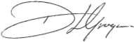

D Grogan, Head Teacher
IMPORTANT INFORMATION

SAFEGUARDING

In this school, the welfare of the child is paramount. This school is committed to safeguarding and promoting the welfare of children and young people and expects all staff and volunteers to share this commitment.

All staff should understand their responsibility to safeguarding and promoting the welfare of children and young people. Staff are responsible for their own actions and behaviour and should avoid any conduct which would lead any reasonable person to question their motivation and intentions. Staff should work, and be seen to work, in an open and transparent way.

Attitudes towards promoting and safeguarding the welfare of children and young people will be scrutinised during the selection process for the post that you have applied for. If you are appointed to this post, information in relation to safeguarding and protecting children and young people will be provided at induction. This practical guidance for safe working practice will provide information about which behaviours constitute safe practice and which behaviours should be avoided.

The post you are applying for is covered by the Rehabilitation of Offenders (Exceptions) Act 1975. If successful, you will be required to apply to the Disclosure and Barring Service for an enhanced disclosure.

Please note that in line with Keeping Children Safe in Education statutory guidance; an online search will be carried out as part of our due diligence on shortlisted candidates. Please note that if shortlisted, we will seek references before you attend the interview.

EQUAL OPPORTUNITIES

We are committed to achieving equal opportunities in the way we deliver services to the community and in our employment arrangements. We expect all employees to understand and promote this policy in their work.

HEALTH & SAFETY

All employees have a responsibility for their own health and safety and that of others when carrying out their duties and must help us to apply our general statement of health and safety policy. Lancashire County Council operates a smoke and vape free policy on all sites.

ATTENDANCE

This school is committed to achieving and maintaining a high level of attendance from all employees through the application of good management practice. The School Leadership Team will monitor overall levels of sickness absences regularly, will support employees during periods of sickness and will arrange for confidential reports to be submitted to Governors. Action will be taken in accordance with the guidelines and procedures adopted by the school to deal with unacceptable levels and frequency of sickness absence. All employees must understand the importance of good attendance and ensure that any sickness absence is kept to a minimum and that during any such absence they do not undertake any activity which is incompatible with the illness or which may delay recovery.

SUBMITTING YOUR APPLICATION

Please complete the application form enclosed and submit electronically to Debbie Saxton, HR Administrator, via email at dsaxton@pchs.lancs.sch.uk.

SCHOOL BUSINESS SUPPORT OFFICER 1 – JOB DESCRIPTION

JOB TITLE: | School Business Support Officer 1
GRADE: | 3
HOURS: | 37 per week (8.00 – 4.00 MTWT, 8.00 – 3.30 F)
CAR USER: | N/A
LOCATION: | Pendle Community High School & College
RESPONSIBLE TO: | School Business Manager
STAFF RESPONSIBLE FOR: | N/A
JOB PURPOSE: | The main objectives to be achieved by the Post holder
Under direction/instruction to provide routine clerical/administrative/word processing/financial support to the school.
MAIN ACTIVITIES: | Accountabilities / responsibilities  Appropriate for this post:
Provide routine clerical/administrative support including:
- Undertake reception duties, including providing a warm, professional welcome to all school visitors, answering telephone and responding to routine queries.
- Provide administrative support to the Senior Leadership Team and wider staff team as required.
- Provide general clerical and administrative support, including word processing, filing routine correspondence, distributing mail, basic reprographics and communications.
- Maintain and update manual and computerised records including, for example, records of free school meals, school trips, registers etc including related data input, website and social media updates.
- Update and maintain school diaries and produce a weekly bulletin.
- Maintain the signing in system including staff / visitor passes and key fobs.
- Maintaining the daily lunch ordering system.
- Undertake such other duties commensurate with the grade and nature of the post as reasonably required by the Senior Leadership Team or direct Line Management.

General
- To work within school policies and procedures.
- To contribute to the provision of an effective environment for learning.
- To support the promotion of positive relationships with parents and outside agencies.
- To attend skills training and participate in personal/performance development as required.
- To take care for own and other people's health and safety.
- To be aware of the confidential nature of issues.
In addition, other duties at the same responsibility level may be interchanged with/added to this list at any time.
AGREED BY: | School Business Manager September 2026

SCHOOL BUSINESS SUPPORT OFFICER 1 – PERSON SPECIFICATION

REQUIREMENTS (based on the job description) |  | Essential (E) or Desirable (D) | Identified by:  Application form (A), Interview (I), Test (T), References (R) or  other (give details)
QUALIFICATIONS
GCSE English Grade 4/C or Equivalent |  | E | A
GCSE Maths Grade 4/C or Equivalent |  | D | A
EXPERIENCE
Experience of Microsoft Office ICT packages |  | E | A/I
KNOWLEDGE, SKILLS & ABILITIES
Ability to work both as part of a team and independently |  | E | A/I/R
Effective communication skills both oral and written |  | E | A/I/R
Ability to prioritise workload and meet agreed deadlines |  | E | A/I/R
OTHER (including special requirements)
Commitment to safeguarding and protecting the welfare of children and young people |  | E | I
Commitment to equality and diversity |  | E | I
Commitment to health and safety |  | E | I
Commitment to attendance at work |  | E | R
Commitment to the inclusion of all children |  | E | I
Please be aware we will always consider your references before confirming a job offer in writing
PREPARED BY: | School Business Manager Oct 2025

CLOSING DATE: | Friday 9th October 12noon
SHORTLISTING DATE: | Friday 9th October
INTERVIEW DATE: | Monday 19th October

